CADSNET
Use case diagram and gameplay flow by attack
Based on the game build of 3 November 2026.

1. Use case diagrams
The Player (Alice, the student) is the main actor. The Attacker (the Ghostline group) is the second actor and only takes part in the parts of the game where a cyber threat happens. Solid arrows connect an actor to a use case; dashed arrows marked «include» or «extend» connect a use case to the steps it includes or the options it can lead to.

System Use Case Diagram
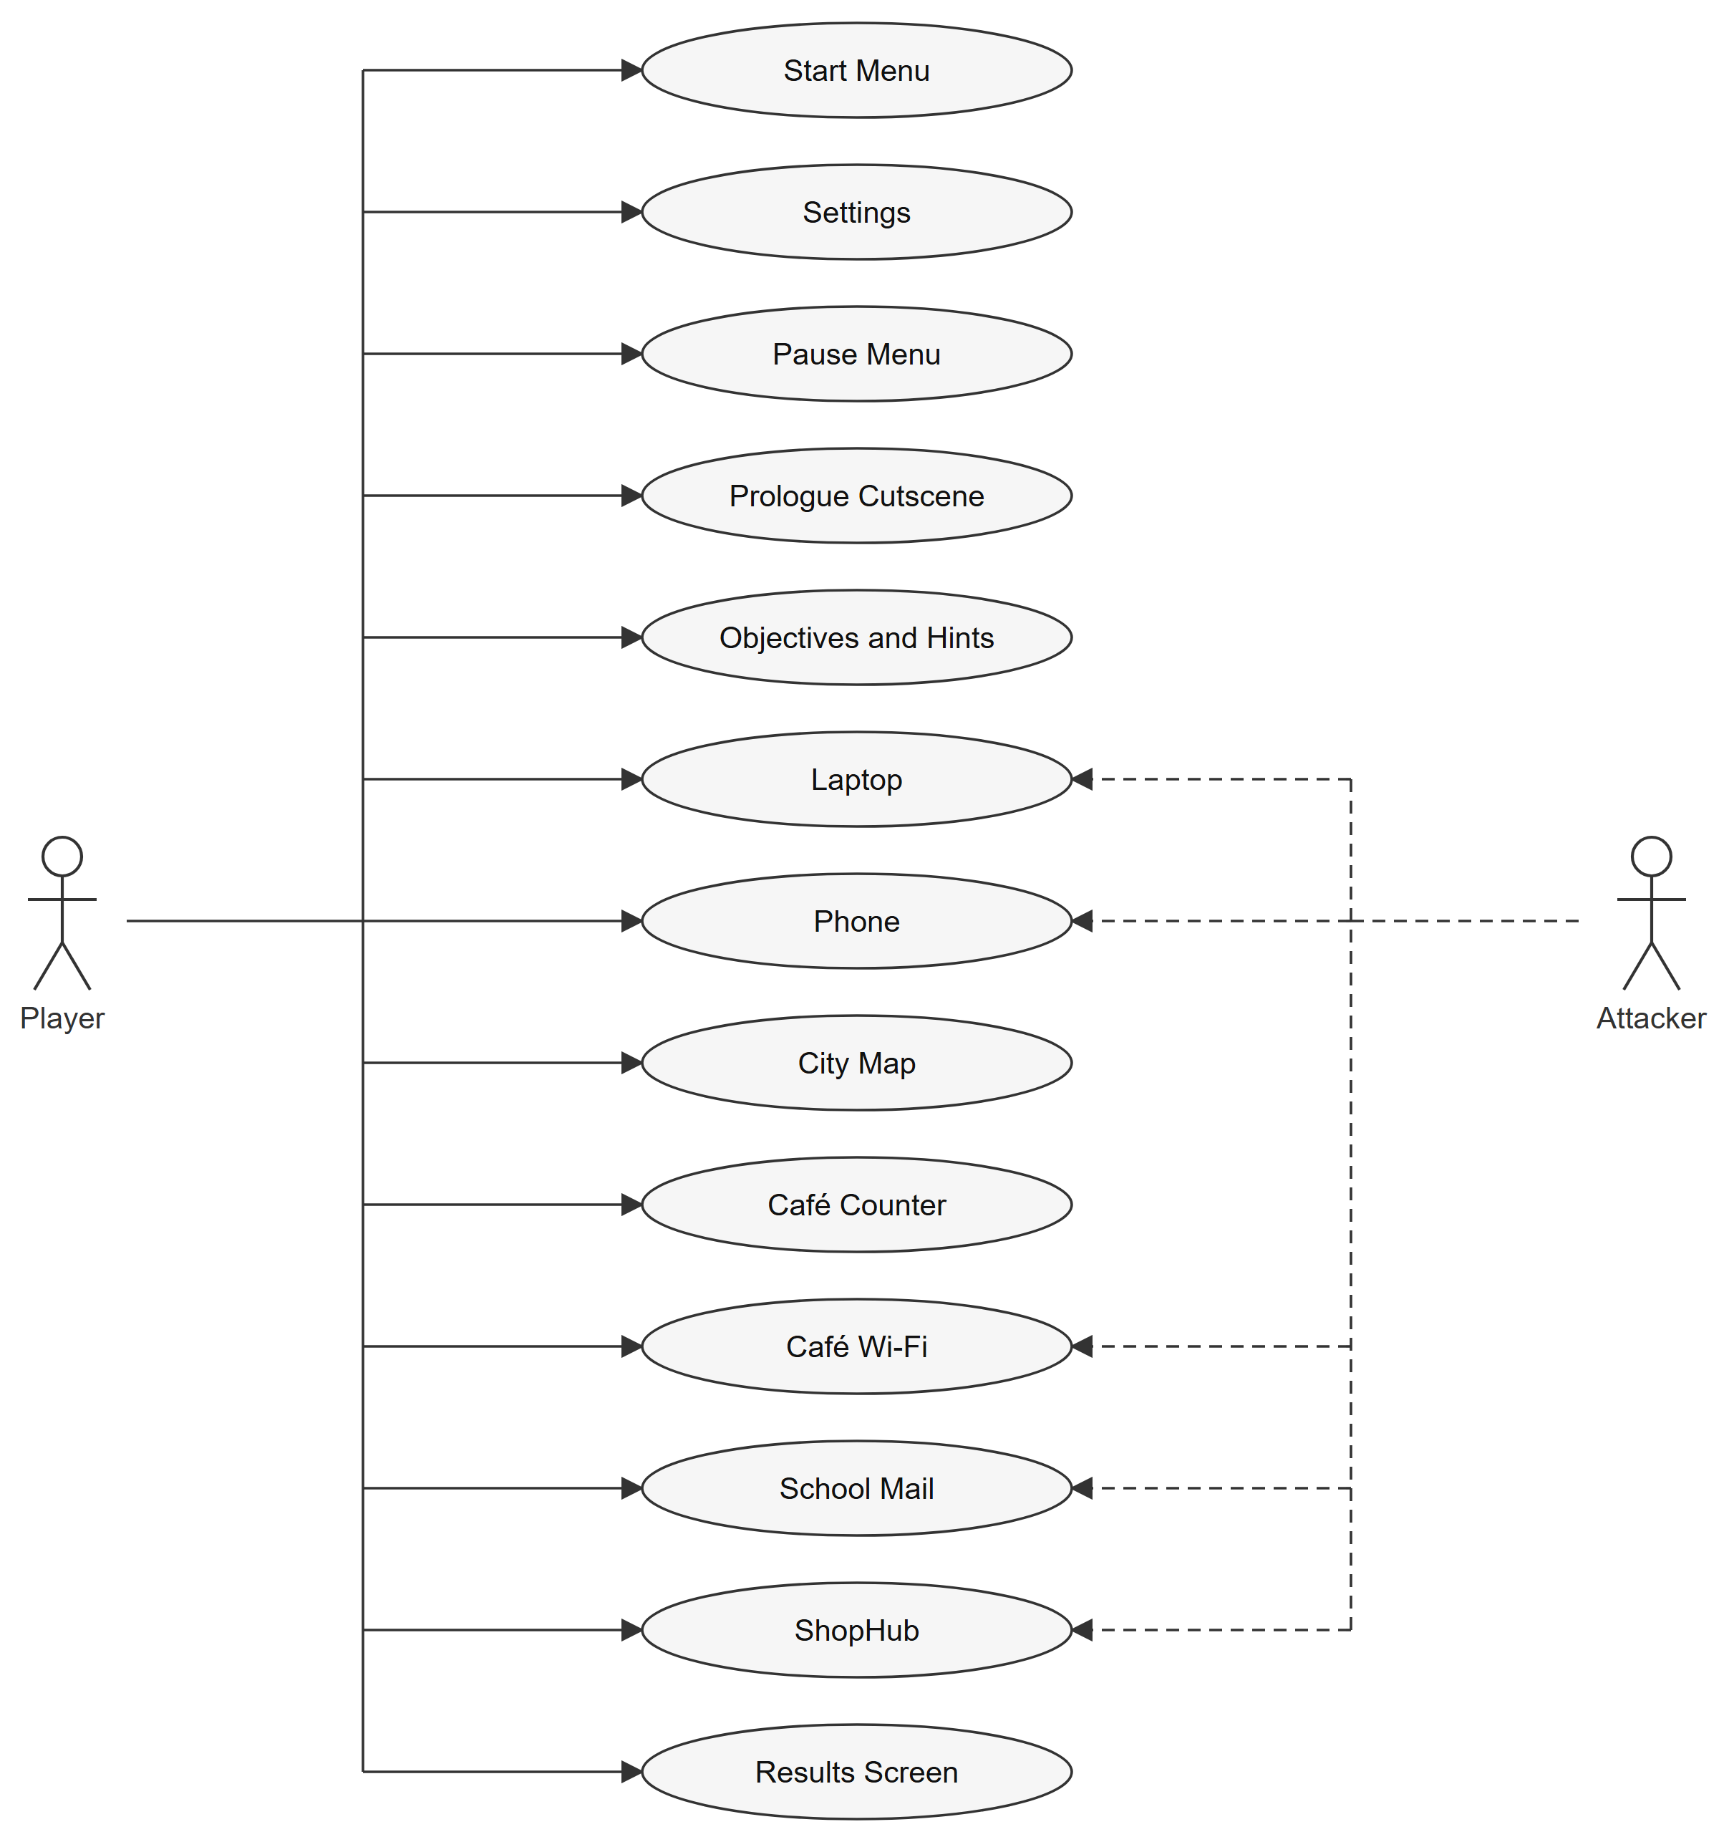
Figure 4.1 System Use Case Diagram

Use Case Diagram of Start Menu
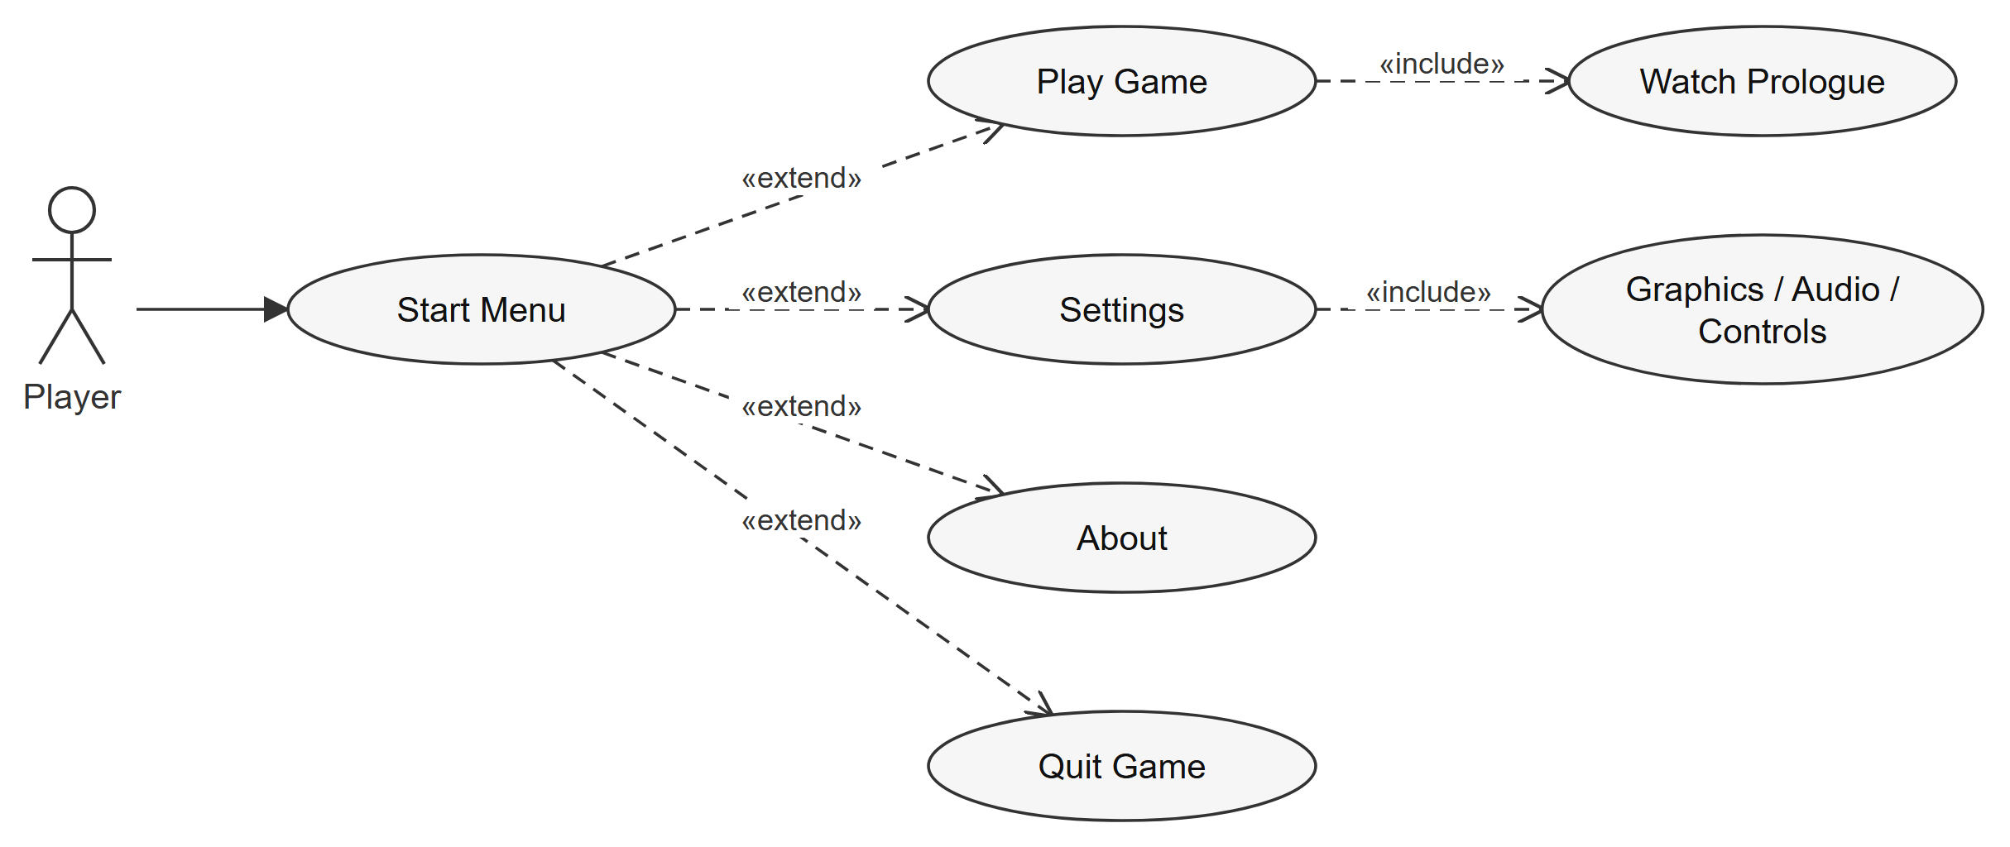
Figure 4.2 CN001 Use Case Diagram of Start Menu

Use Case Diagram of Back Up the Thesis (Laptop and Flash Drive)
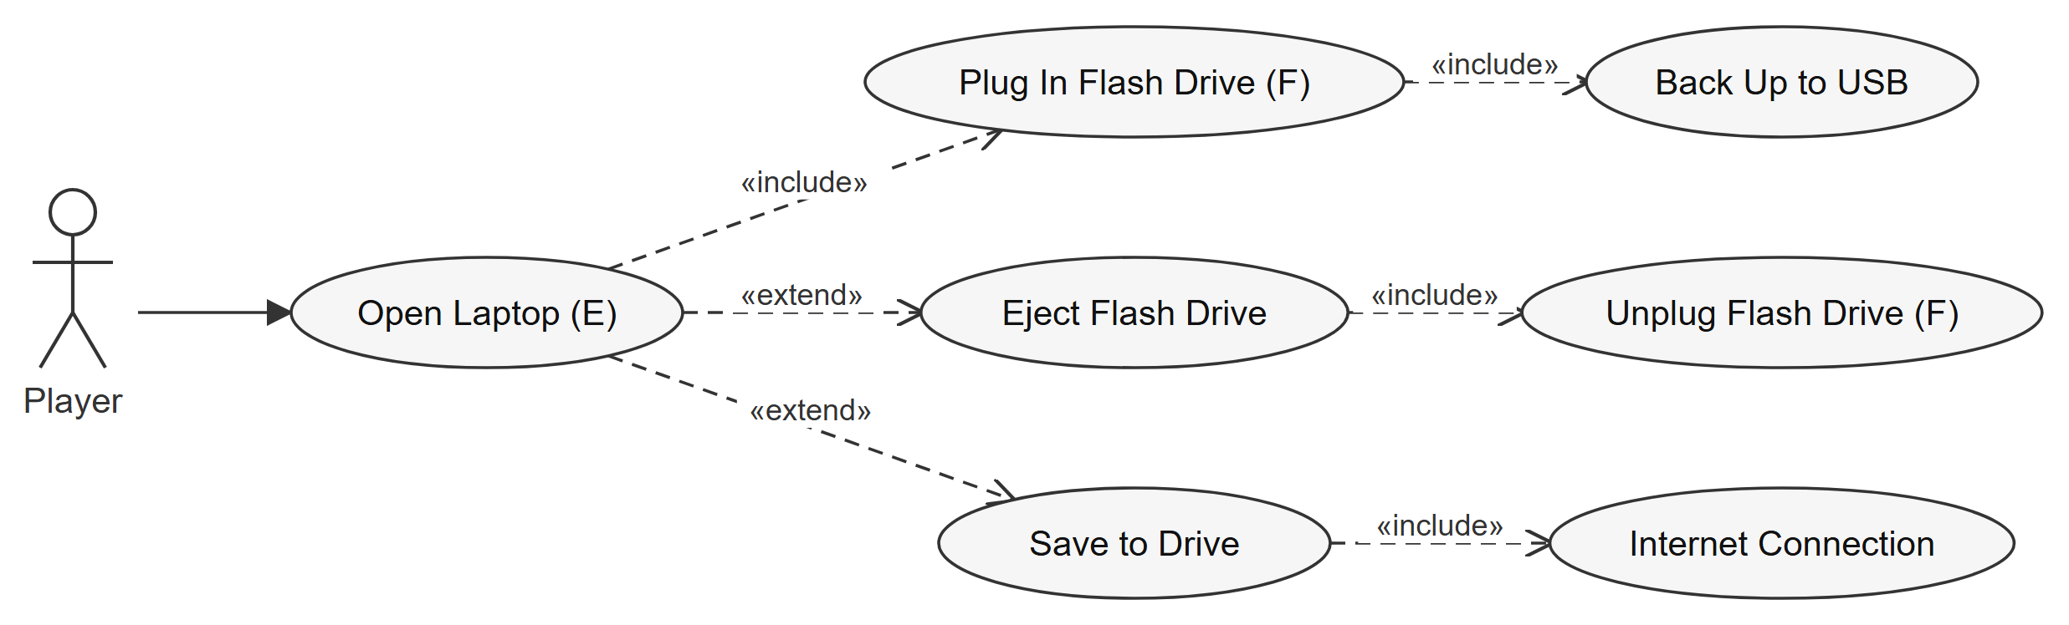
Figure 4.3 CN002 Use Case Diagram of Back Up the Thesis (Laptop and Flash Drive)

Use Case Diagram of Turn On 2FA (Phone)
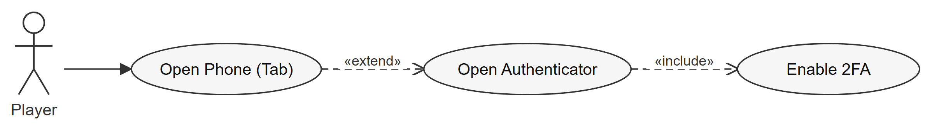
Figure 4.4 CN003 Use Case Diagram of Turn On 2FA (Phone)

Use Case Diagram of Connect to the Café Wi-Fi
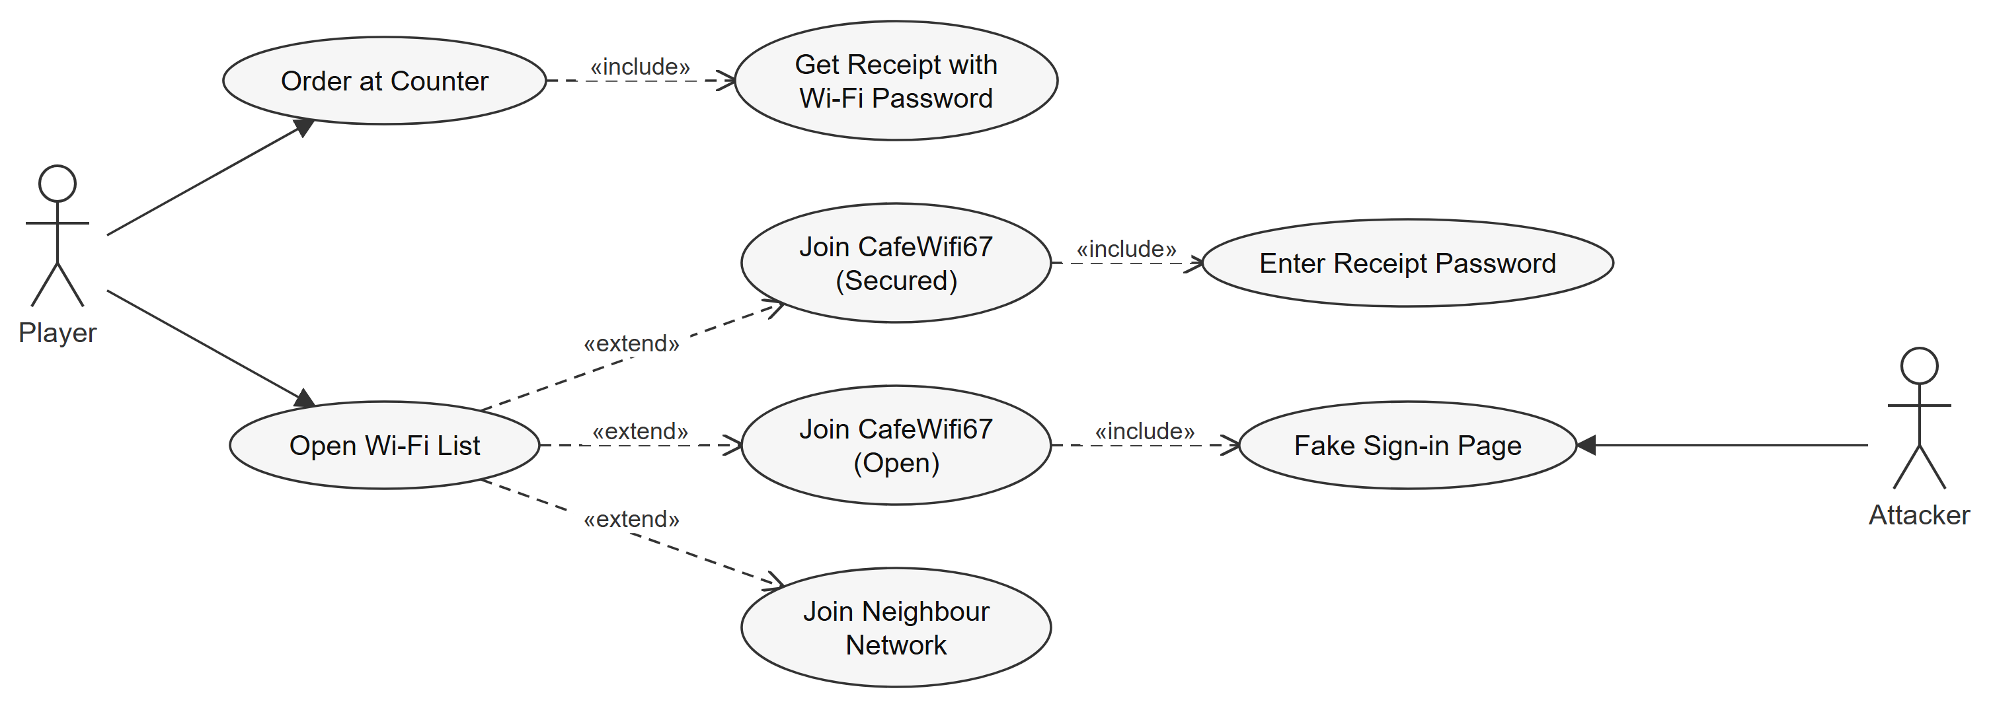
Figure 4.5 CN004 Use Case Diagram of Connect to the Café Wi-Fi

Use Case Diagram of Send the Thesis (School Mail)
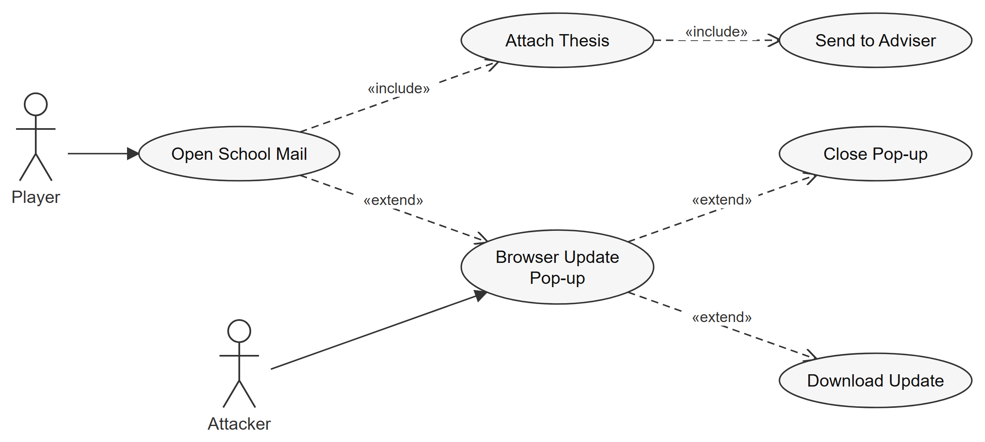
Figure 4.6 CN005 Use Case Diagram of Send the Thesis (School Mail)

Use Case Diagram of Sign-in Alert
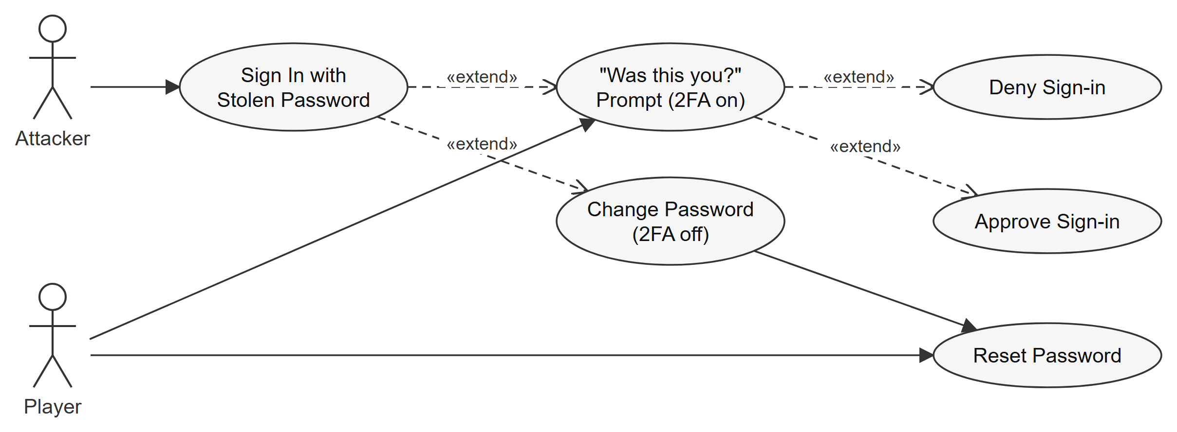
Figure 4.7 CN006 Use Case Diagram of Sign-in Alert

Use Case Diagram of Kai's Money Request
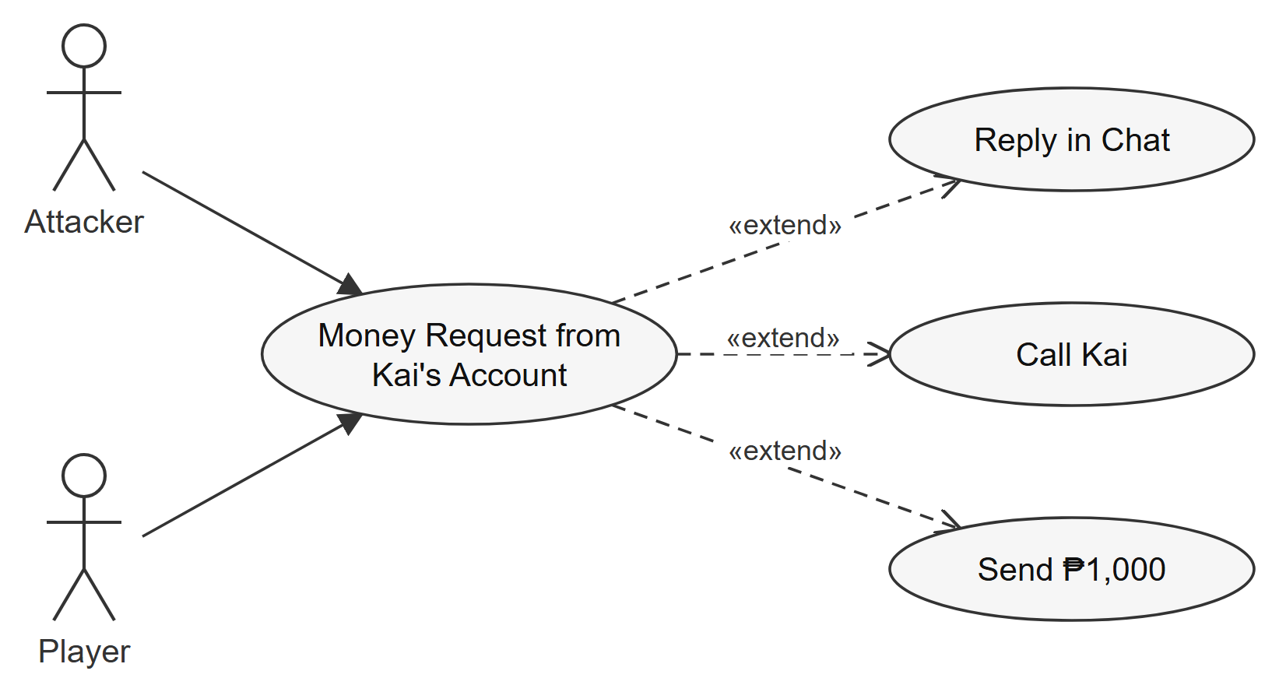
Figure 4.8 CN007 Use Case Diagram of Kai's Money Request

Use Case Diagram of Locked Files (Ransomware)
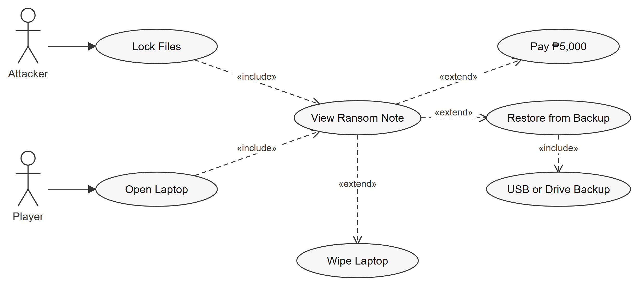
Figure 4.9 CN008 Use Case Diagram of Locked Files (Ransomware)

Use Case Diagram of ShopHub
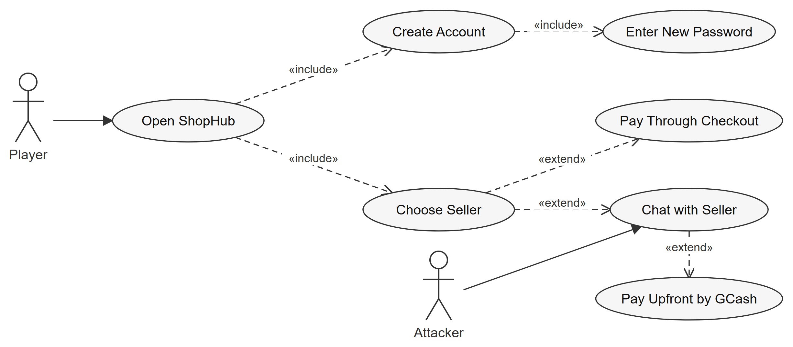
Figure 4.10 CN009 Use Case Diagram of ShopHub

Use Case Diagram of Results and Ending
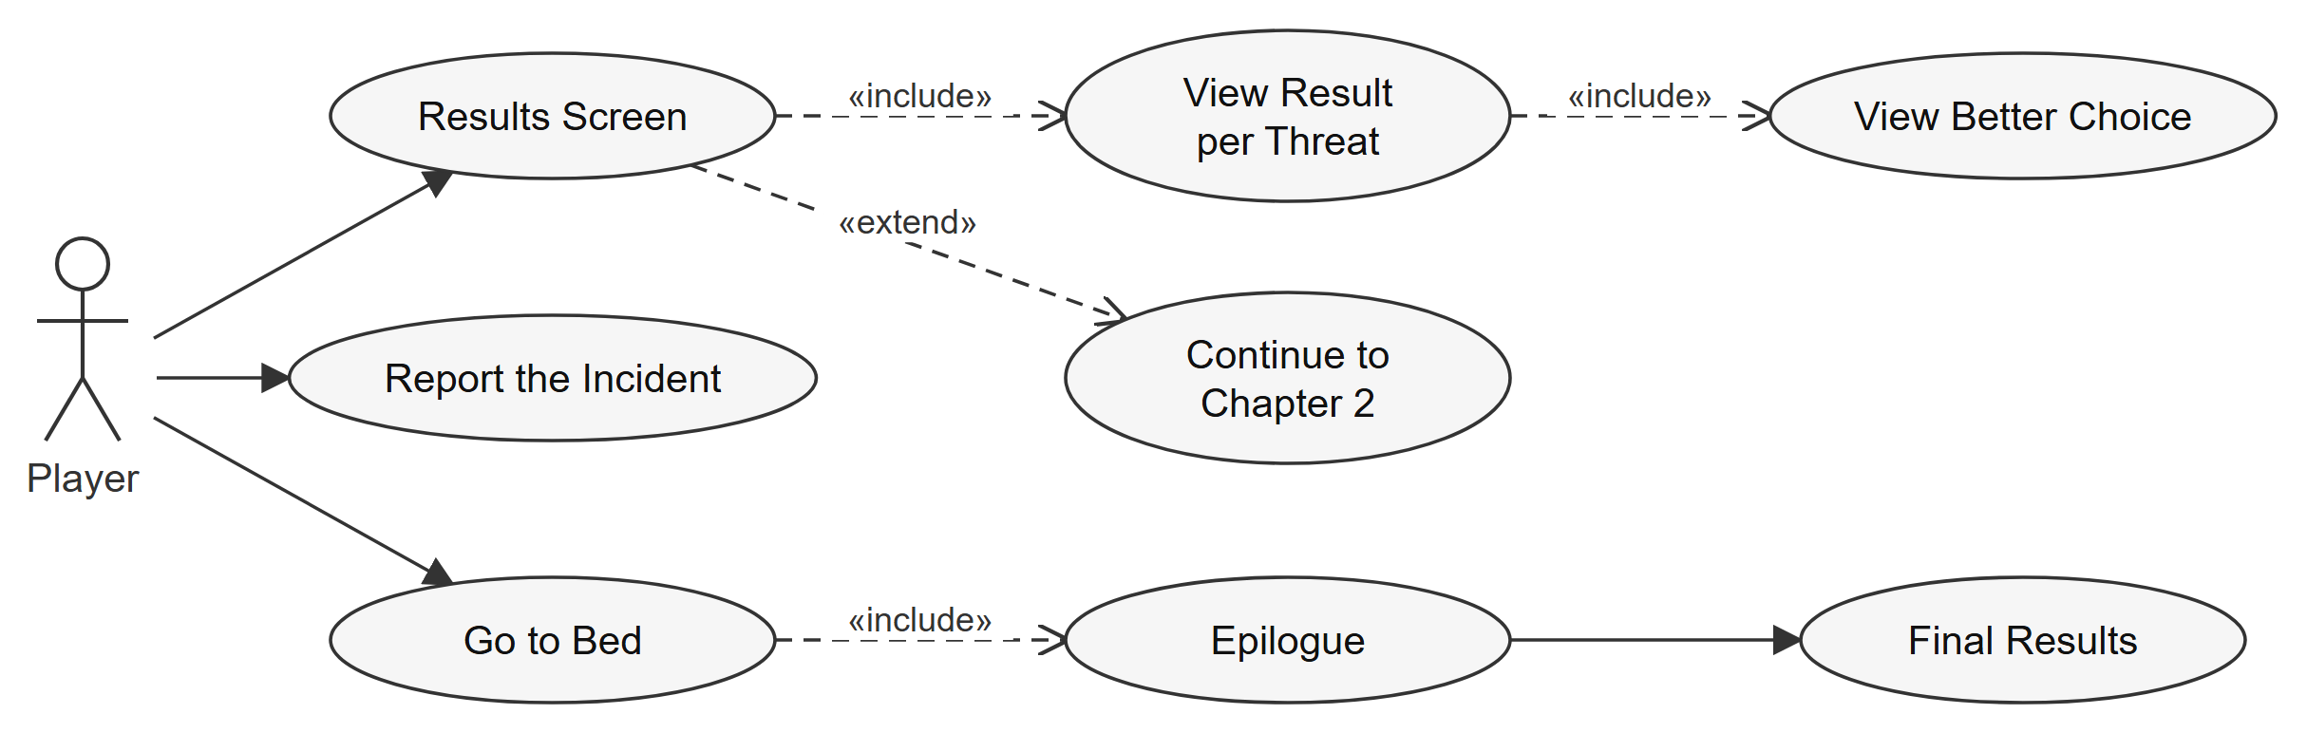
Figure 4.11 CN010 Use Case Diagram of Results and Ending

2. Story order
The game is played in this order. Each attack in section 3 happens inside one of these segments.
Segment | Where | Attacks and habits
Prologue | Alice's room, 11:47 PM | Story setup: Kai's texts, Ghostline on the TV news
Chapter 1 · Home | House, 9:04 AM | Back up your files, Two-factor authentication
Chapter 1 · Café | City and café | Fake café Wi-Fi (evil twin), Fake browser update; thesis is sent
Chapter 1 results | Results screen | Safe / Recovered / Compromised per item, with the better choice
Chapter 2 · That night | House, 11:40 PM | Stolen password used to sign in, Friend's hacked account, Files locked for ransom, Reused password, Fake online seller
Ending | Laptop and bed | Report the incident, "Two weeks later..." epilogue, final results

3. Gameplay flow by attack
Each part below covers one attack or habit: a table with where it happens, what the player sees and each result, then a flowchart of the choices on the next page. The colours in the tables and charts mean:
- Green, Safe: the right choice.
- Amber, Recovered: a mistake that was caught or fixed in time.
- Red, Compromised: the attack worked.
- Grey dashed box: an effect that shows up later in the story.
Some attacks depend on earlier ones: the stolen login comes from the fake Wi-Fi, the ransomware from the fake update, and 2FA and the backup decide how bad those get.

3.1 Back up your files
Where | Chapter 1 · Home (USB) and café (Drive)
Attack | Data loss (prepares for ransomware)
What the player sees | The thesis can't be sent at home because there is no internet. The flash drive is in the living room; F plugs it into the laptop. Back-up to USB copies the thesis; Eject in the taskbar, then F, unplugs it. Save to Drive only works once online at the café.
Safe | Two backups: the flash drive and the school Drive.
Recovered | One backup. Better than none, but one lost or locked copy means the work is gone.
Compromised | Left home with a single copy of the thesis.
Later effect | In Chapter 2, a backup lets the player restore the thesis after ransomware. Without one, wiping the laptop loses it.
Lesson | Keep at least two backups in different places: one offline (a flash drive you unplug) and one in the cloud.
Source | CISA, #StopRansomware Guide (2023): maintain offline, encrypted backups

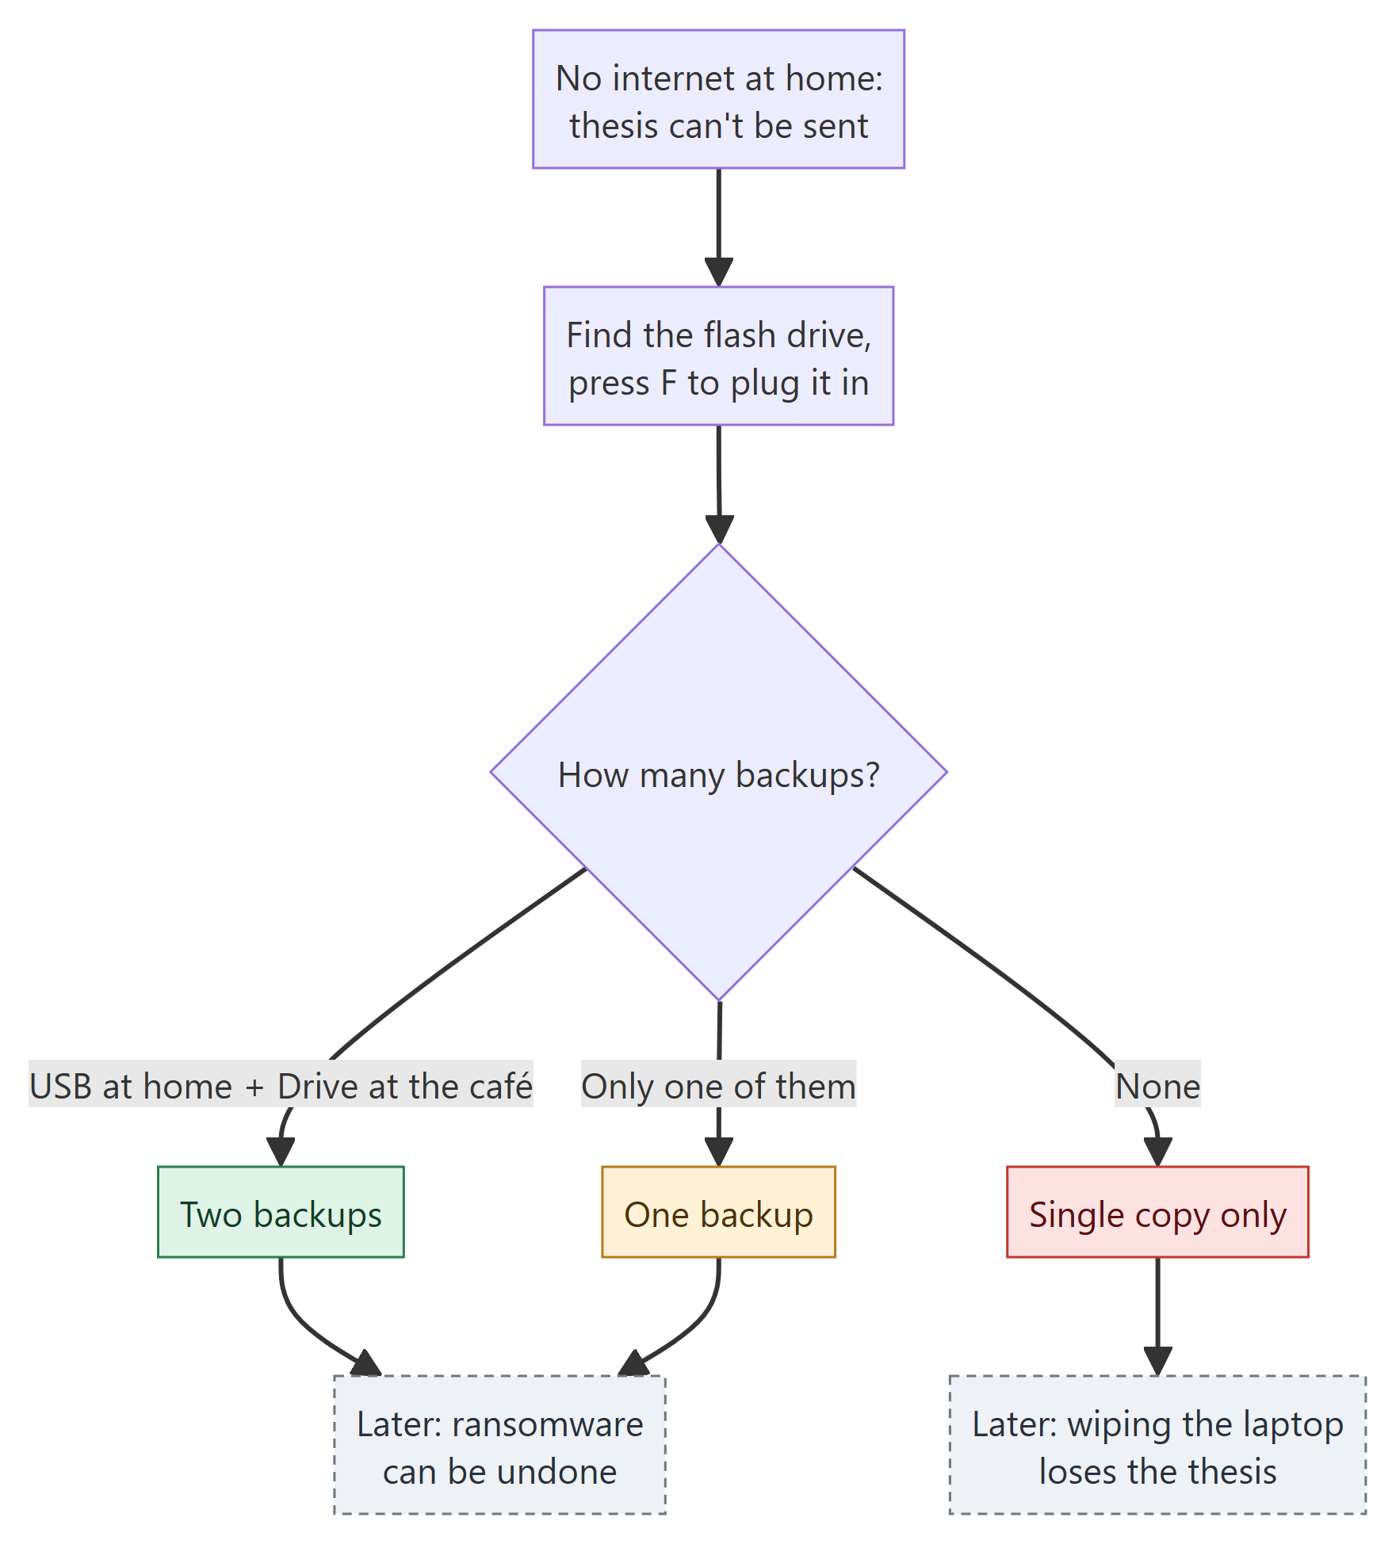
Figure 4.12 Flowchart of Back up your files

3.2 Two-factor authentication
Where | Chapter 1 · Home, after the backup
Attack | Account takeover (prepares for the stolen login)
What the player sees | Alice says she could turn on 2FA on her phone. The phone offers to set up the authenticator.
Safe | 2FA on: a stolen password alone is not enough to get into the account.
Compromised | The account is protected by a password only.
Later effect | Decides what happens in the Chapter 2 sign-in alert and the ShopHub password leak.
Lesson | Turn on MFA for school, email and banking accounts.
Source | CISA, Secure Our World: "Turn On MFA"; Microsoft Security Blog (Aug 2019)

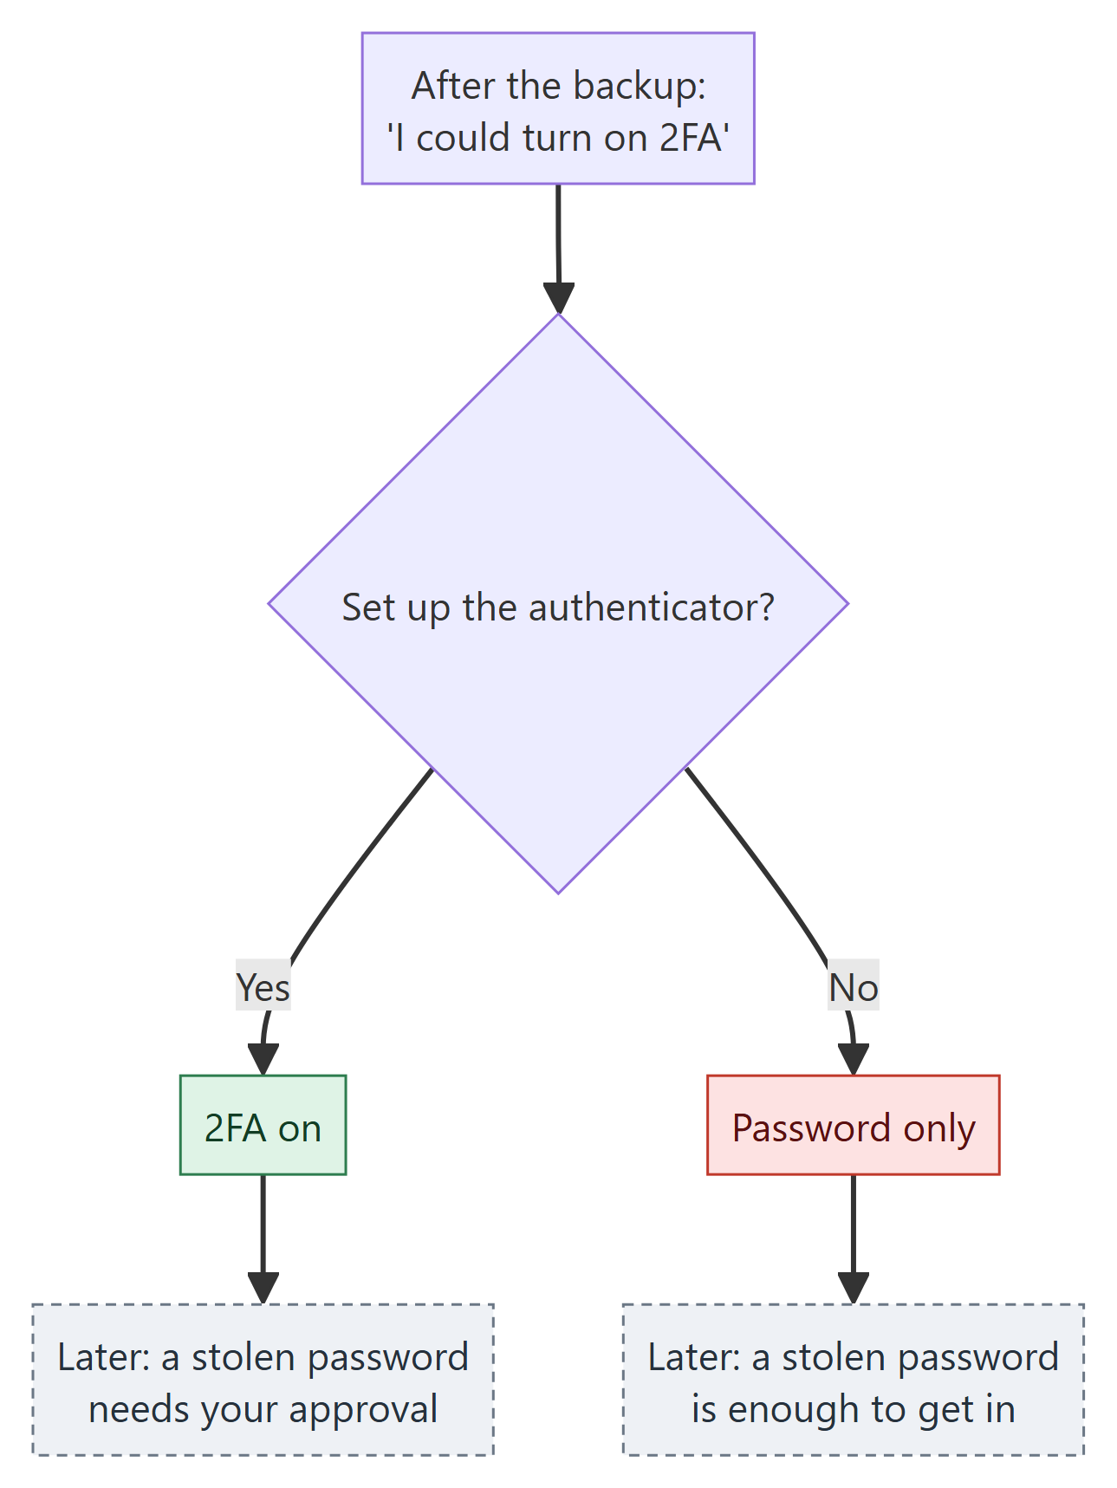
Figure 4.13 Flowchart of Two-factor authentication

3.3 Fake café Wi-Fi (evil twin)
Where | Chapter 1 · Café
Attack | Evil twin access point with a fake sign-in page (credential theft)
What the player sees | Three networks: CafeWifi67 (Secured), CafeWifi67 (Open) and the neighbour's PLDT_HOME_7A2C. The café receipt shows the real password. The open copy opens a sign-in page asking for the school email and password.
Safe | Joined the secured CafeWifi67 with the receipt password.
Recovered | Opened the open copy's sign-in page but backed out without typing the login.
Compromised | Typed the school email and password into the fake sign-in page.
Later effect | A stolen login triggers the sign-in alert in Chapter 2.
Lesson | Attackers copy a café's exact Wi-Fi name. Join the network that asks for the password on your receipt, and never type your email password into a Wi-Fi sign-in page.
Source | FTC, "Are Public Wi-Fi Networks Safe? What You Need To Know" (2023)

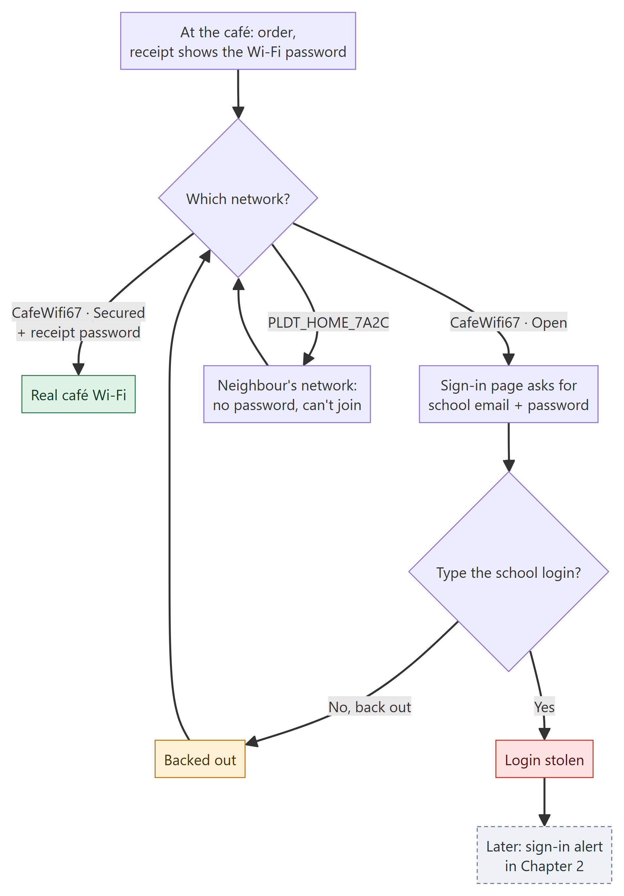
Figure 4.14 Flowchart of Fake café Wi-Fi (evil twin)

3.4 Fake browser update
Where | Chapter 1 · Café, when the school mail page loads
Attack | Malware delivered as a fake update (leads to ransomware)
What the player sees | A pop-up in the browser says the browser is out of date, with X and Download.
Safe | Closed the pop-up; nothing was installed.
Compromised | Downloaded the "update" from the web page.
Later effect | The download was ransomware: in Chapter 2 the laptop's files are locked.
Lesson | Only update software through your system's own updater or the developer's official site.
Source | CISA, Secure Our World: "Update Software"

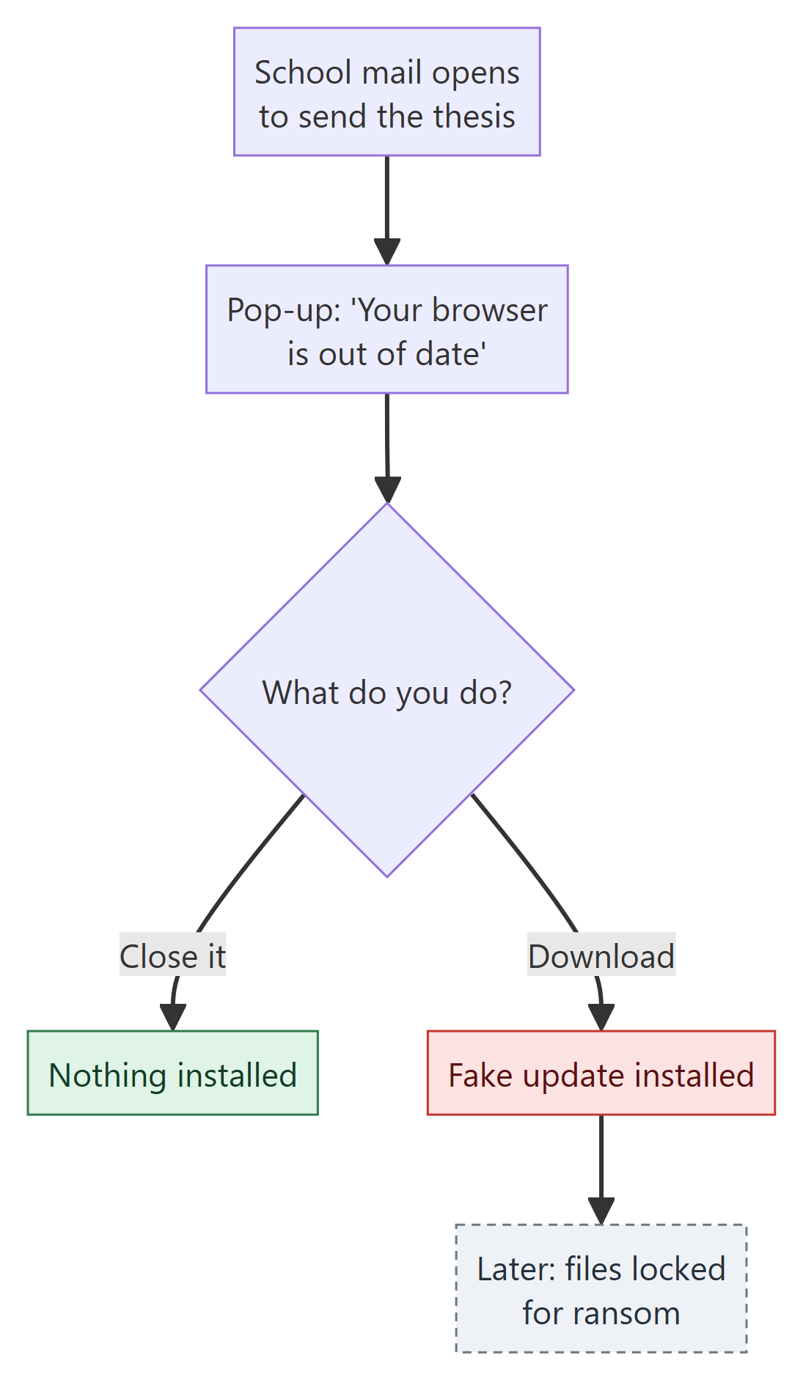
Figure 4.15 Flowchart of Fake browser update

3.5 Stolen password used to sign in
Where | Chapter 2 · Phone, only if the login was stolen at the café
Attack | Account takeover with a stolen password
What the player sees | With 2FA: a "Was this you?" prompt with a 10-second timer. Without 2FA: a "Your password was changed" notice.
Recovered | 2FA on and the player pressed Deny: the attacker stayed out. Change the password.
Compromised | Approved the sign-in, let the timer run out, or had no 2FA.
Lesson | Never approve a sign-in request you didn't start: deny it, then change your password.
Source | CISA, "Implementing Number Matching in MFA Applications" (2022)

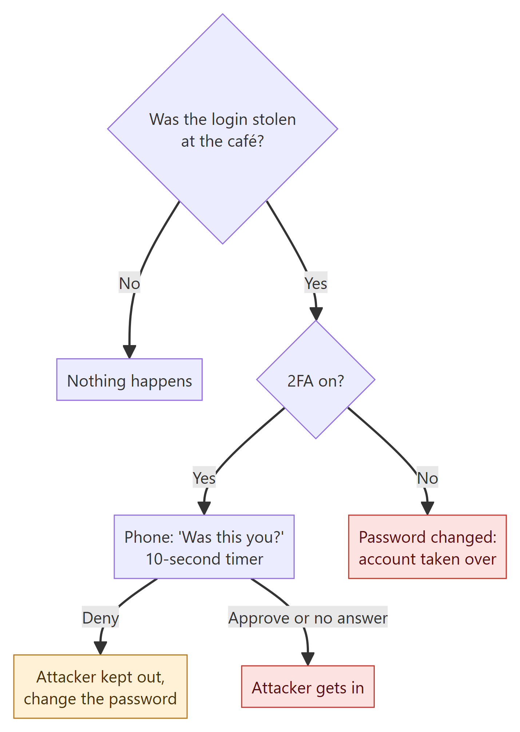
Figure 4.16 Flowchart of Stolen password used to sign in

3.6 Friend's hacked account asks for money
Where | Chapter 2 · Phone messages
Attack | Impersonation through a hijacked friend's account
What the player sees | Kai's account asks for ₱1,000. The player can reply in the chat, call Kai, or send the money.
Safe | Called Kai, learned the account was hacked, sent nothing.
Compromised | Sent ₱1,000 to the scammer.
Later effect | Replying in the same chat only reaches the scammer ("yes it's me"), so it proves nothing and the choice stays open.
Lesson | When a friend's account suddenly asks for money, verify through another channel, like a phone call.
Source | FTC, "How to Recover Your Hacked Email or Social Media Account"

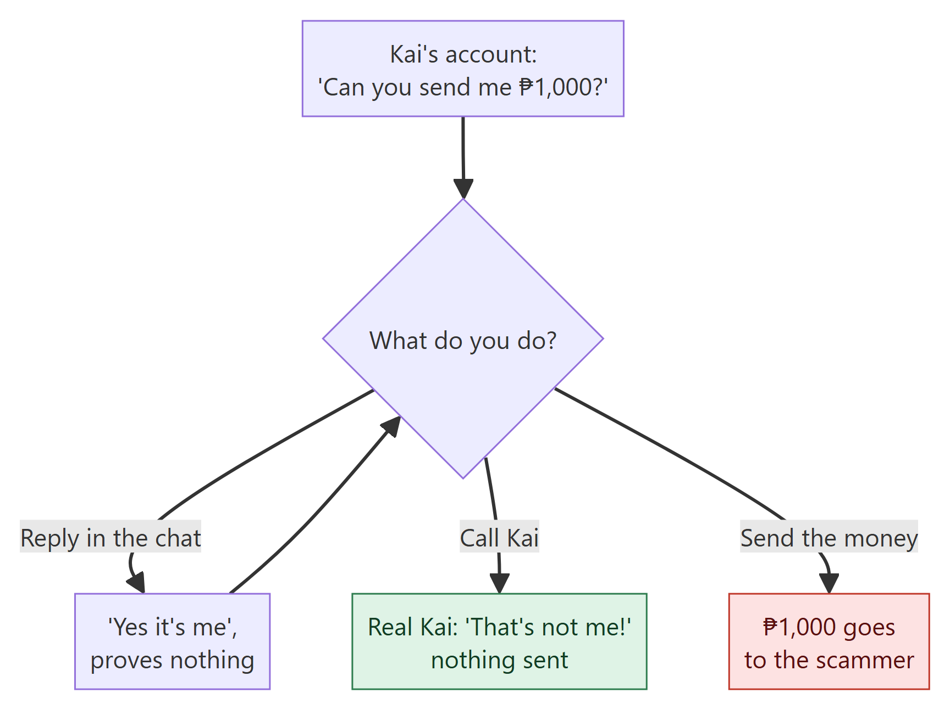
Figure 4.17 Flowchart of Friend's hacked account asks for money

3.7 Files locked for ransom
Where | Chapter 2 · Laptop, only if the fake update was installed
Attack | Ransomware
What the player sees | The laptop's files are locked with a demand for ₱5,000. Choices: pay, restore from backup (only with a backup), or wipe the laptop.
Safe | Didn't pay: restored the thesis from the USB or Drive backup.
Recovered | Didn't pay: wiped the laptop with no backup, so the thesis is lost.
Compromised | Paid. The attackers asked for more and nothing unlocked.
Lesson | Never pay a ransom. An offline backup is what lets you recover.
Source | CISA, #StopRansomware Guide (2023)

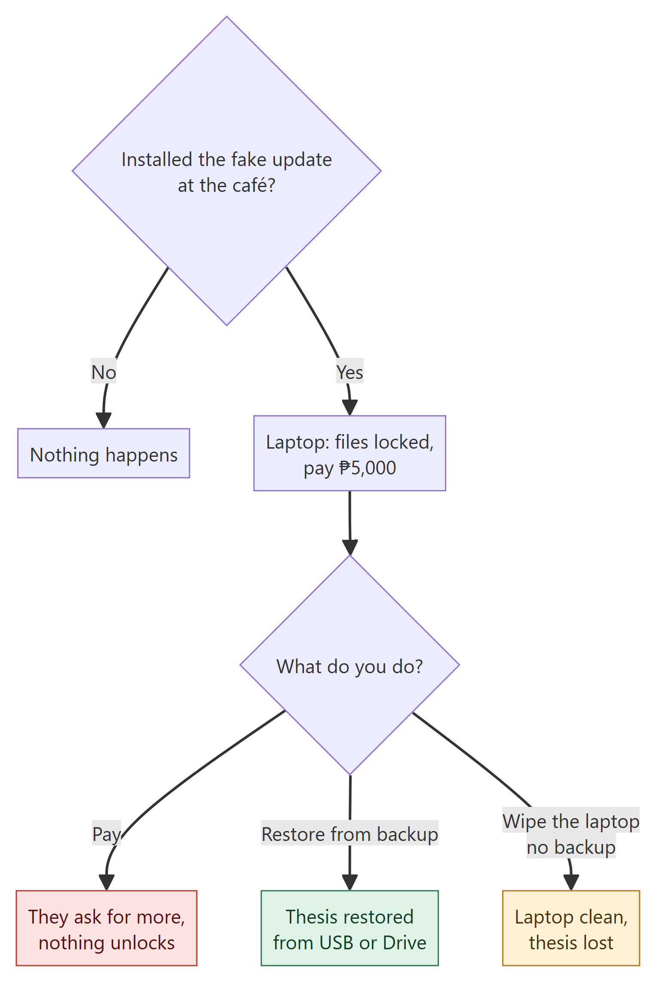
Figure 4.18 Flowchart of Files locked for ransom

3.8 Reused password
Where | Chapter 2 · Laptop, ShopHub sign-up
Attack | Password reuse exposed by a third-party breach
What the player sees | ShopHub asks for a new account password. The player can make a new long one or reuse the school password.
Safe | Made a new, long password just for ShopHub.
Compromised | Reused the school password.
Later effect | After the laptop closes, ShopHub is breached and the school account is attacked again: with 2FA the player gets a "Was this you?" prompt to deny, without it the account is taken over.
Lesson | Use a different, long password for every account (CISA recommends at least 16 characters). A password manager remembers them.
Source | CISA, Secure Our World: "Use Strong Passwords"

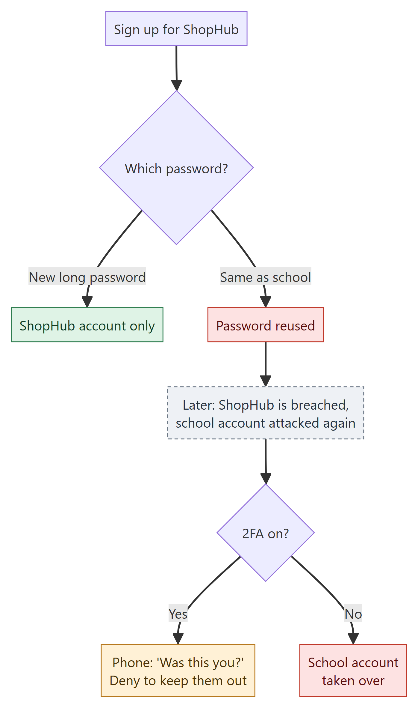
Figure 4.19 Flowchart of Reused password

3.9 Fake online seller
Where | Chapter 2 · Laptop, ShopHub
Attack | Online selling scam
What the player sees | Buying a calculator. The official store has years of good reviews; gadget.deals.ph is new, has no reviews, is far too cheap and asks for GCash upfront. Its profile picture is the Ghostline ghost from the café stranger's laptop.
Safe | Bought from the official store through checkout.
Recovered | Opened the too-cheap seller's chat but backed out.
Compromised | Paid gadget.deals.ph upfront by GCash; the item never came.
Lesson | Check reviews and account age, be wary of prices far below market, and use the platform's checkout or cash on delivery.
Source | FTC, "Buying From an Online Marketplace"; PNP-ACG: online selling scams were the most common cybercrime in 2024–2025

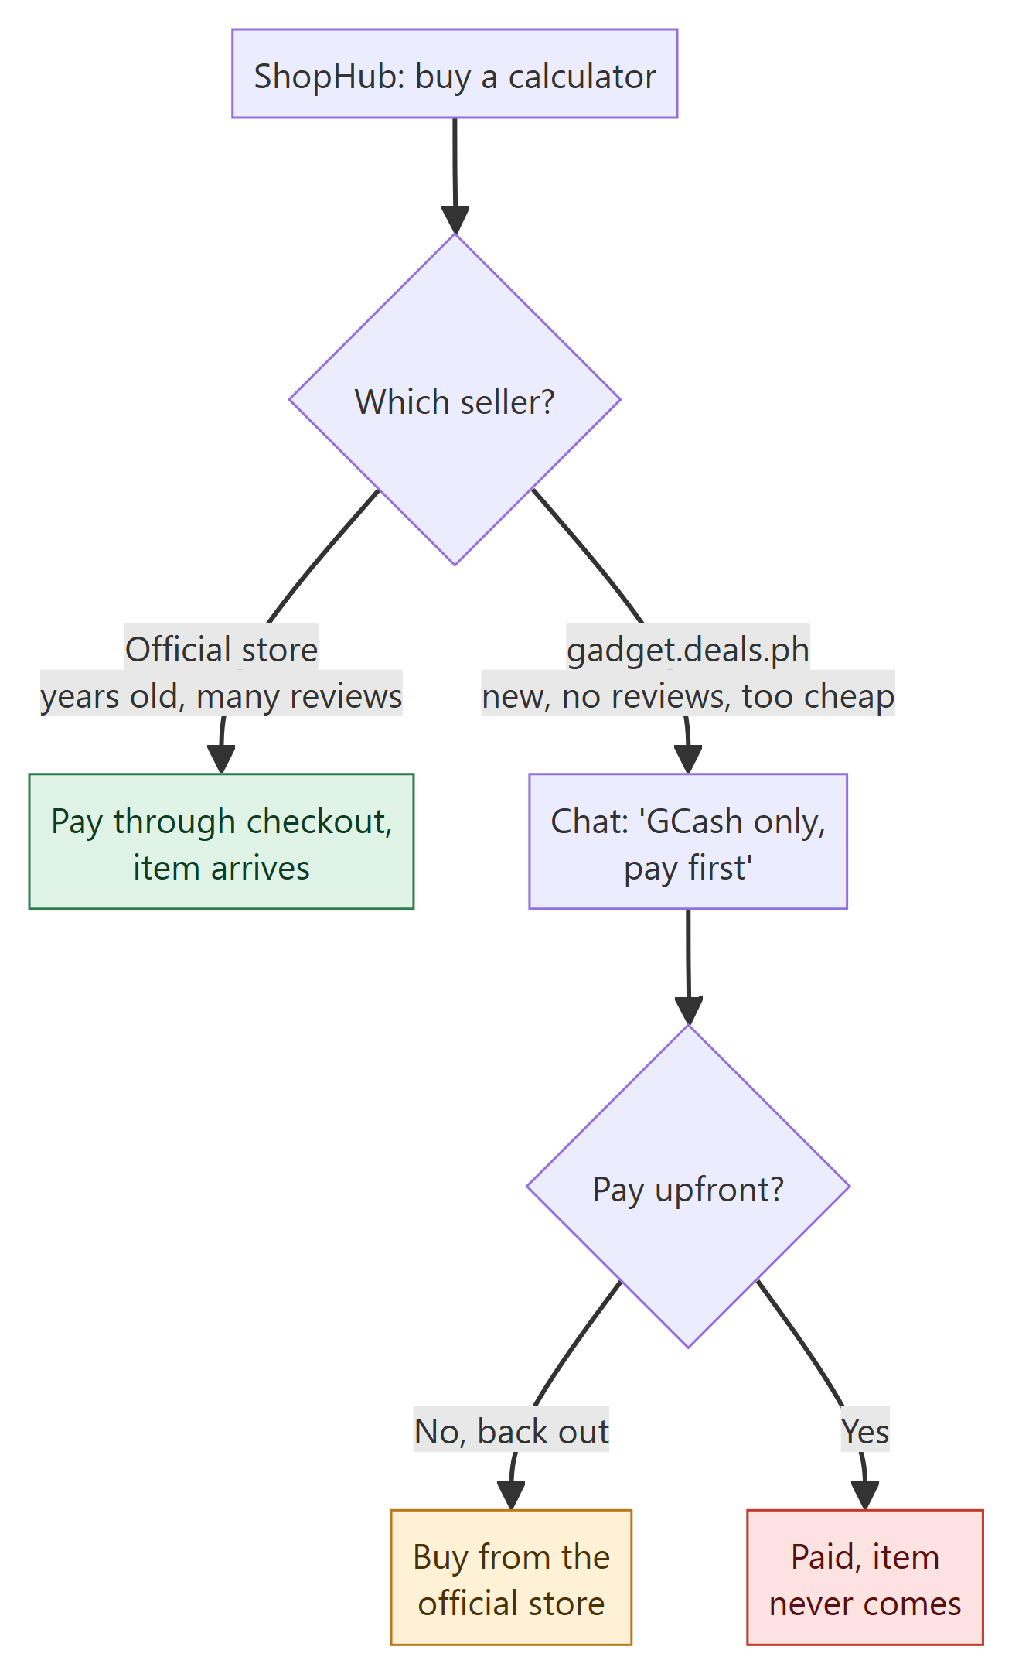
Figure 4.20 Flowchart of Fake online seller

